

**Cloud Deployment Models**

**Name:** Pratham Kandari

**Sap Id:** 500097663

**Batch:** 7

**LAB- 6**

**User and Project Management**

Step 1) Login to your Openstack Dashboard.

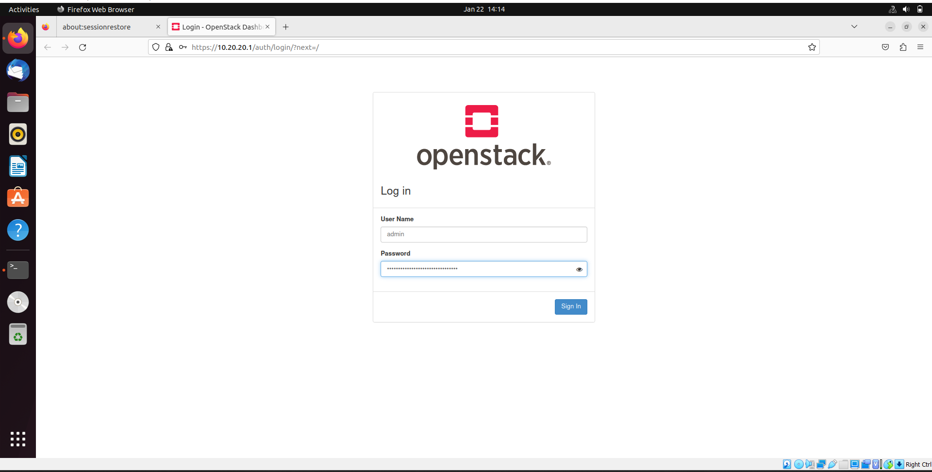

Step 2) Go to Identity -> Projects-> create projects.

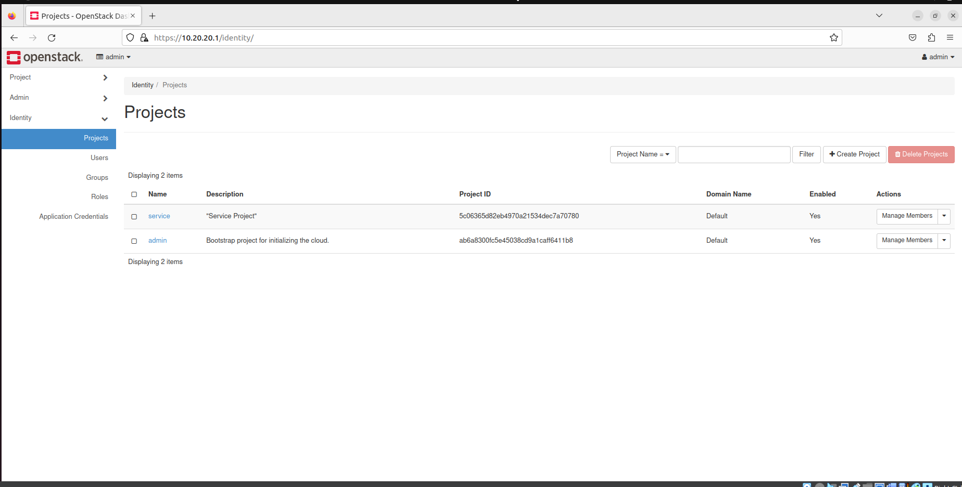

Step 3) Give it a name and create project.

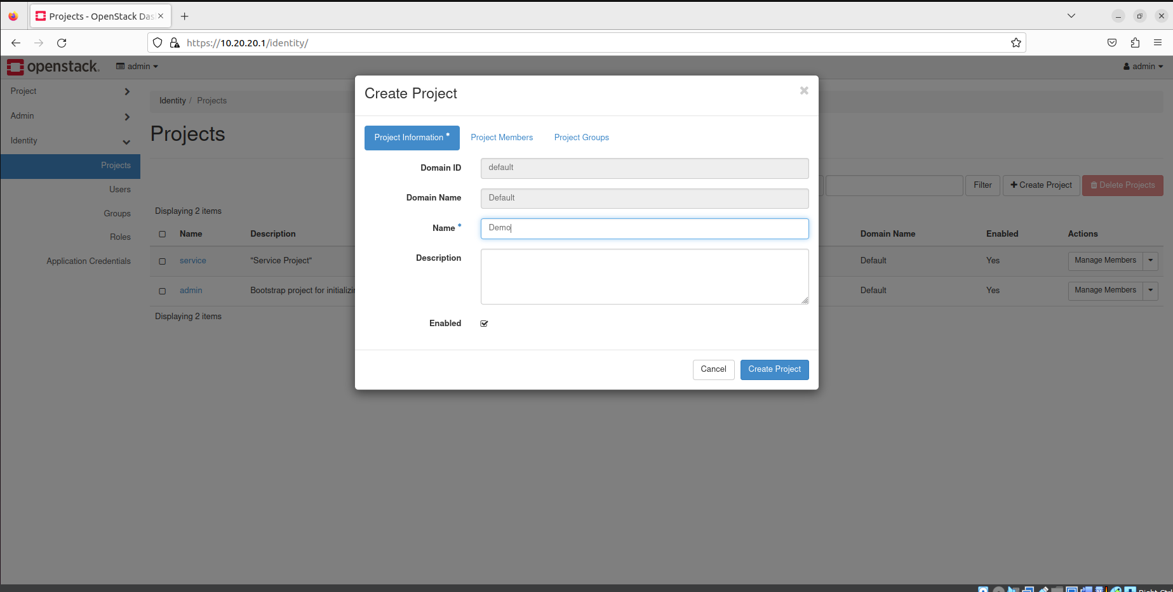

Step 4) Project will be created.

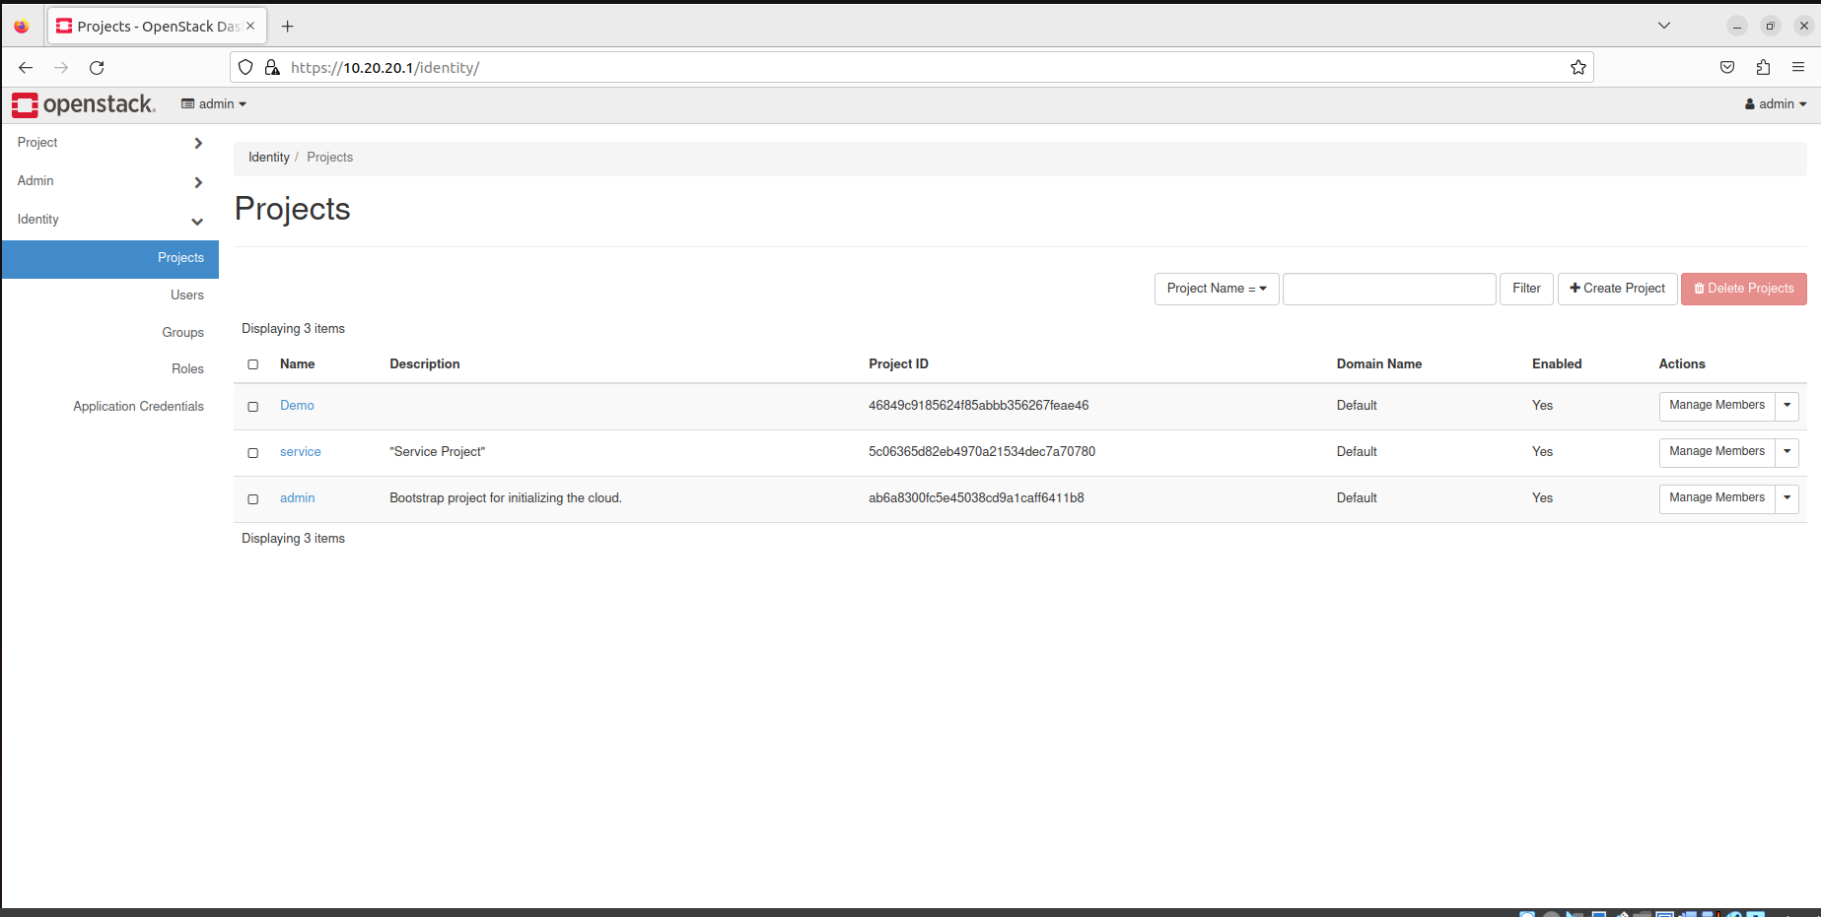

Step 5) go to Users, click on create users.

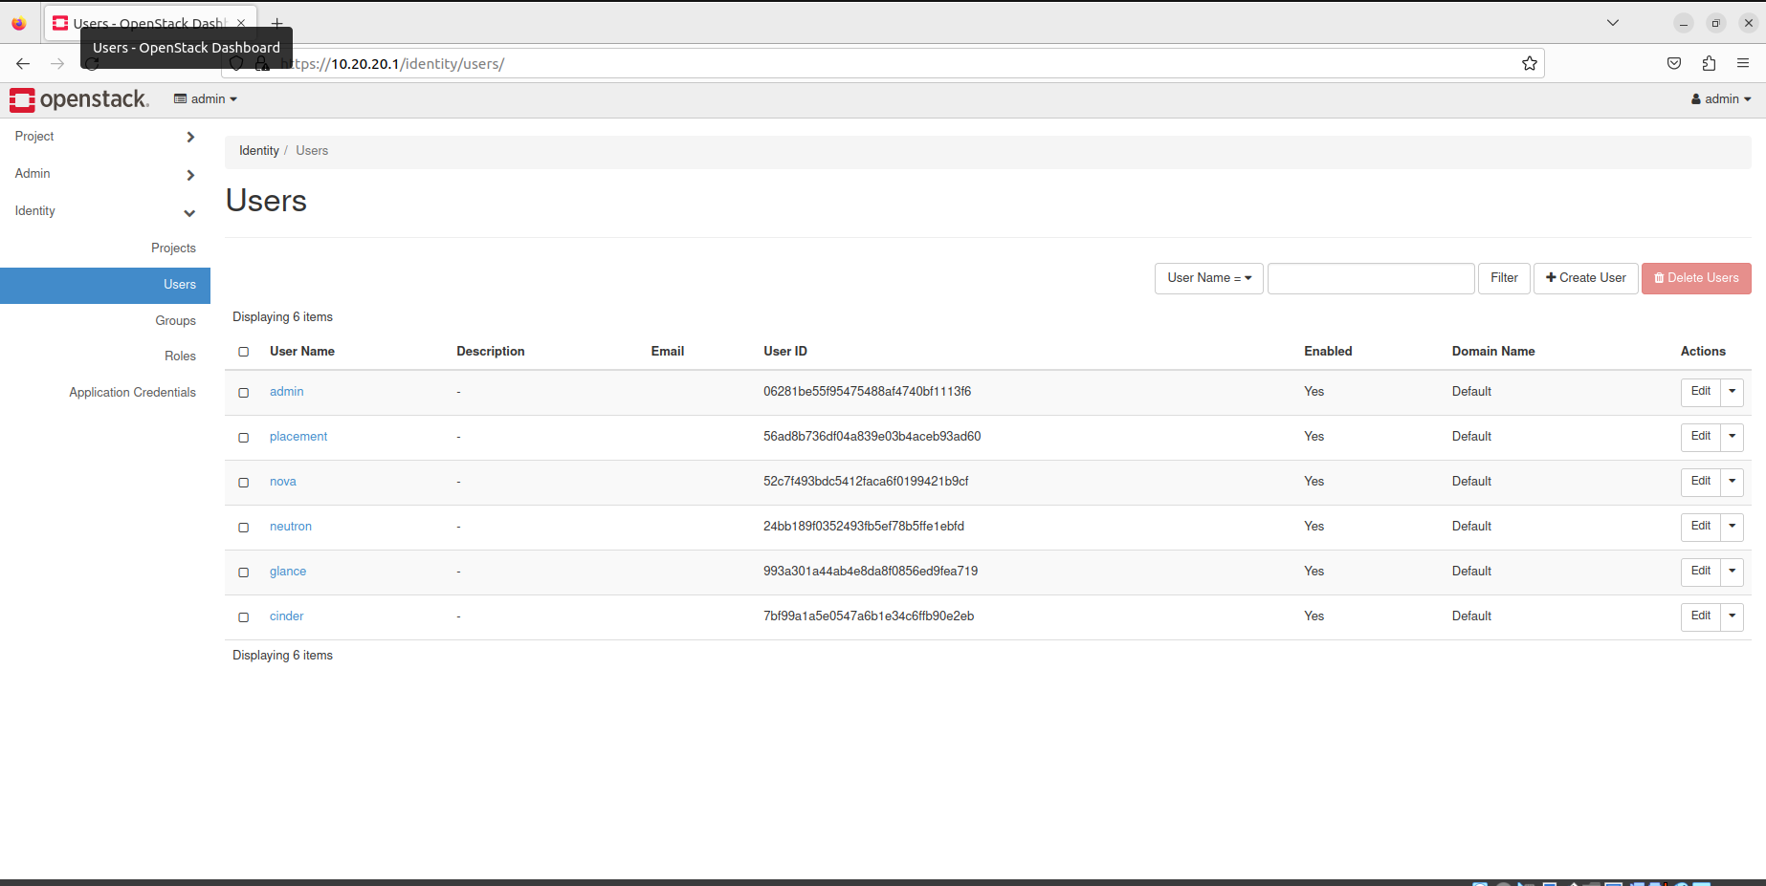

Step 6) Give the user a name, password, and select your project created and role as admin.

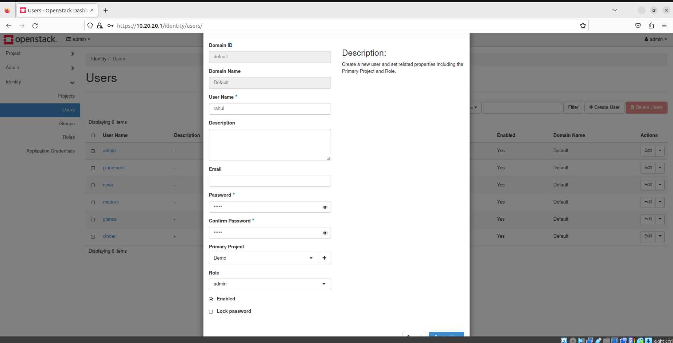

Step 7) User will be created.

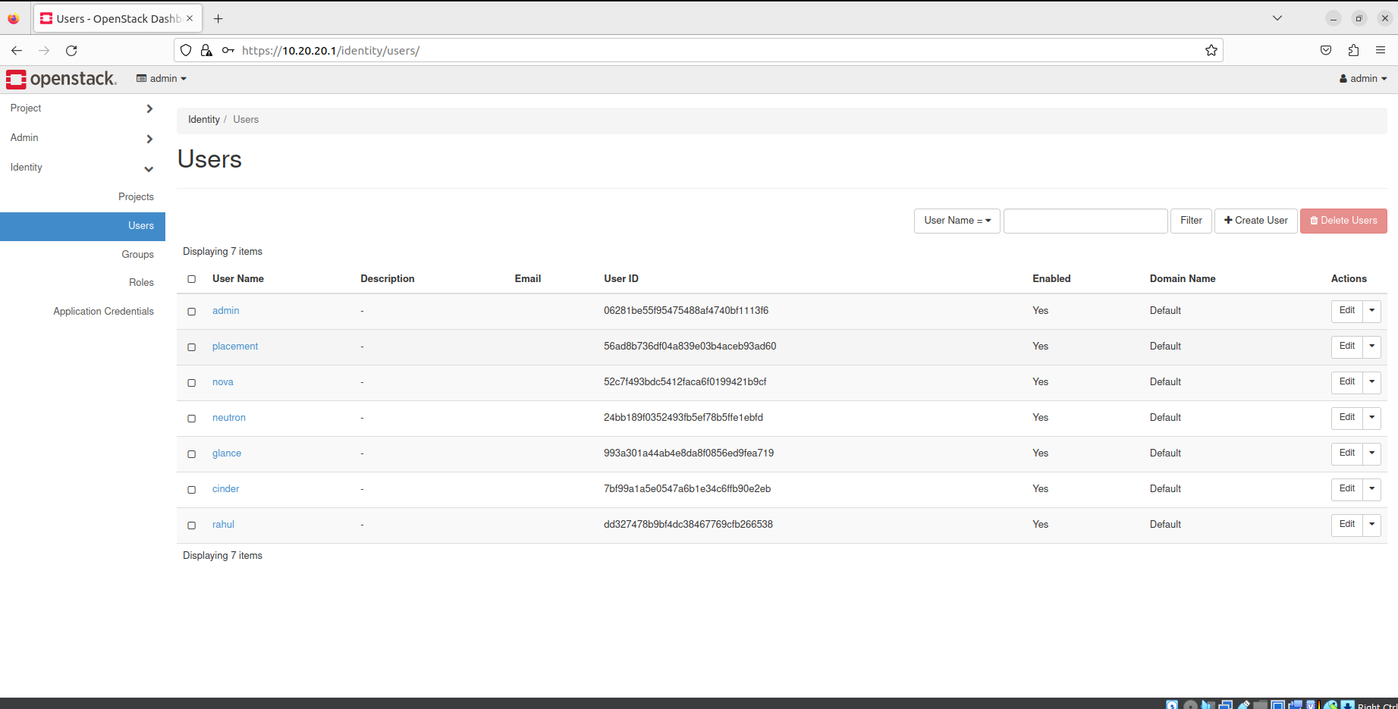

Step 8) Now go to Networks, copy an associated Ip from networks and click on create networks.

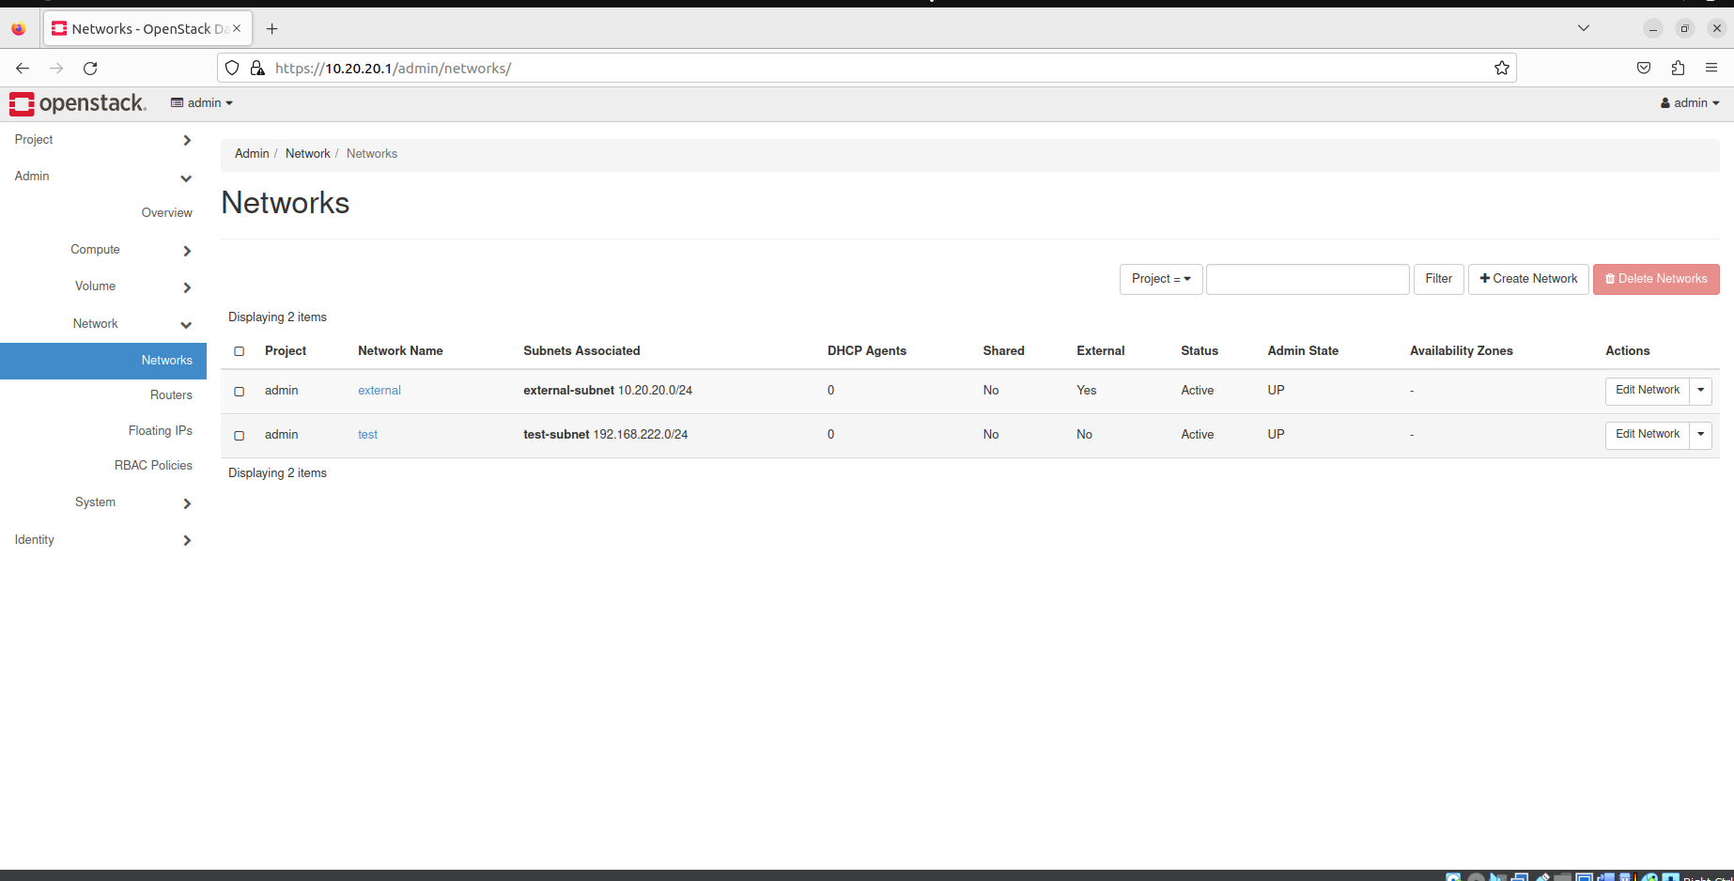

Step 9) Give it a name, select project you created and select shared.

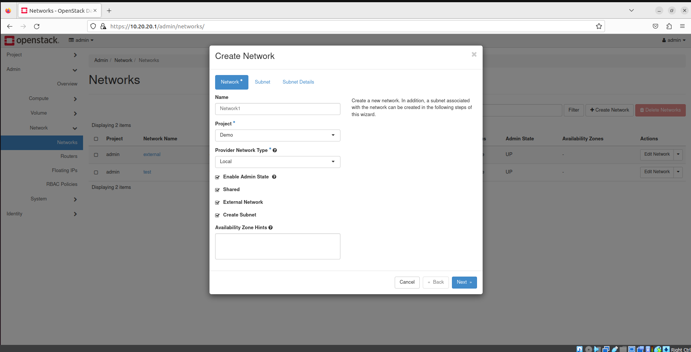

Step 10) Give subnet a name and give it a IP to allocate(paste it from before).

Click on next.

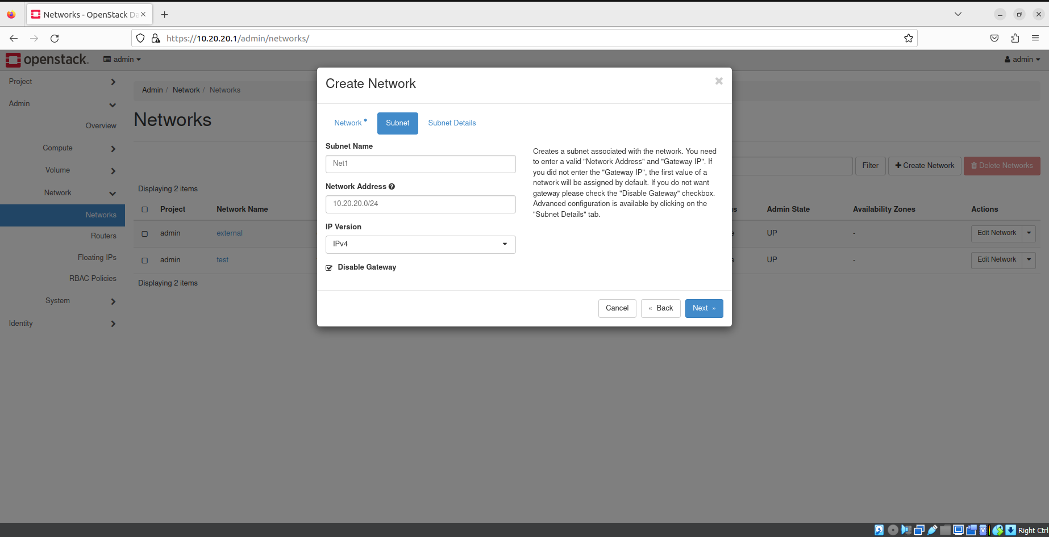

Step 11) And create it.

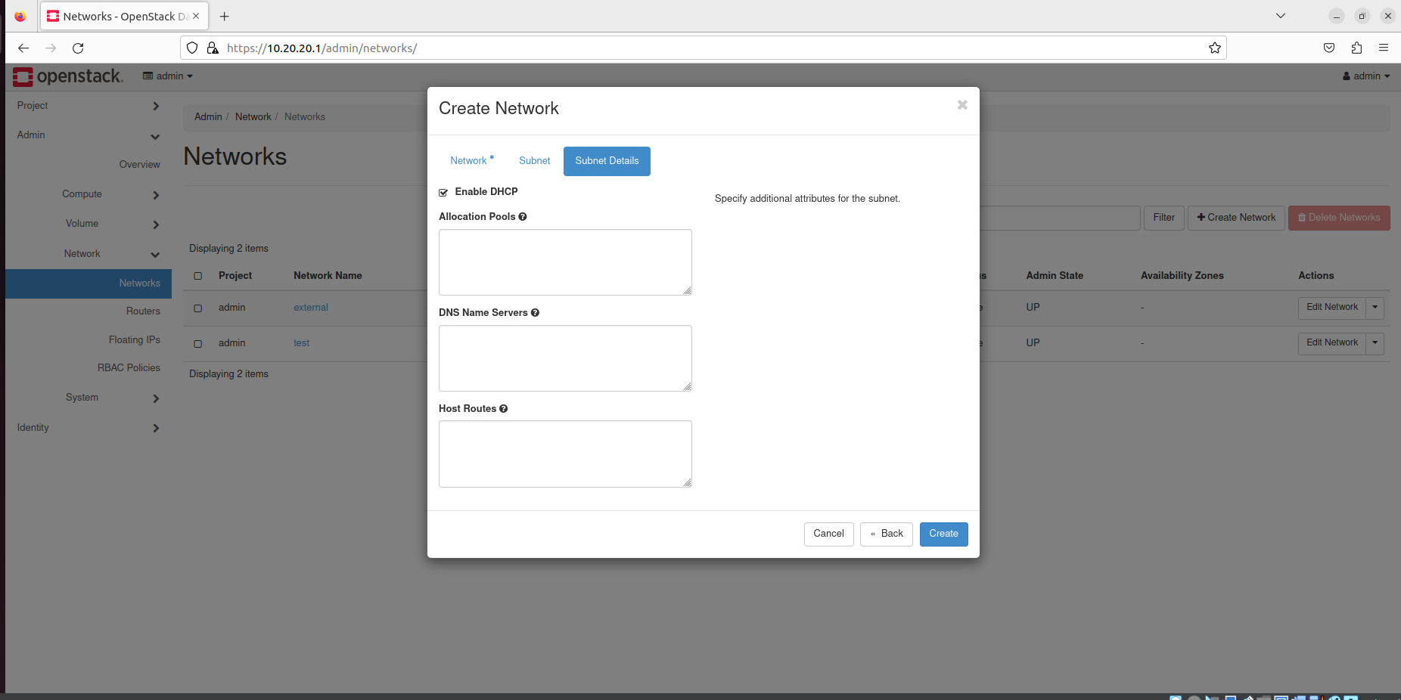

Step 12) Network will be created.

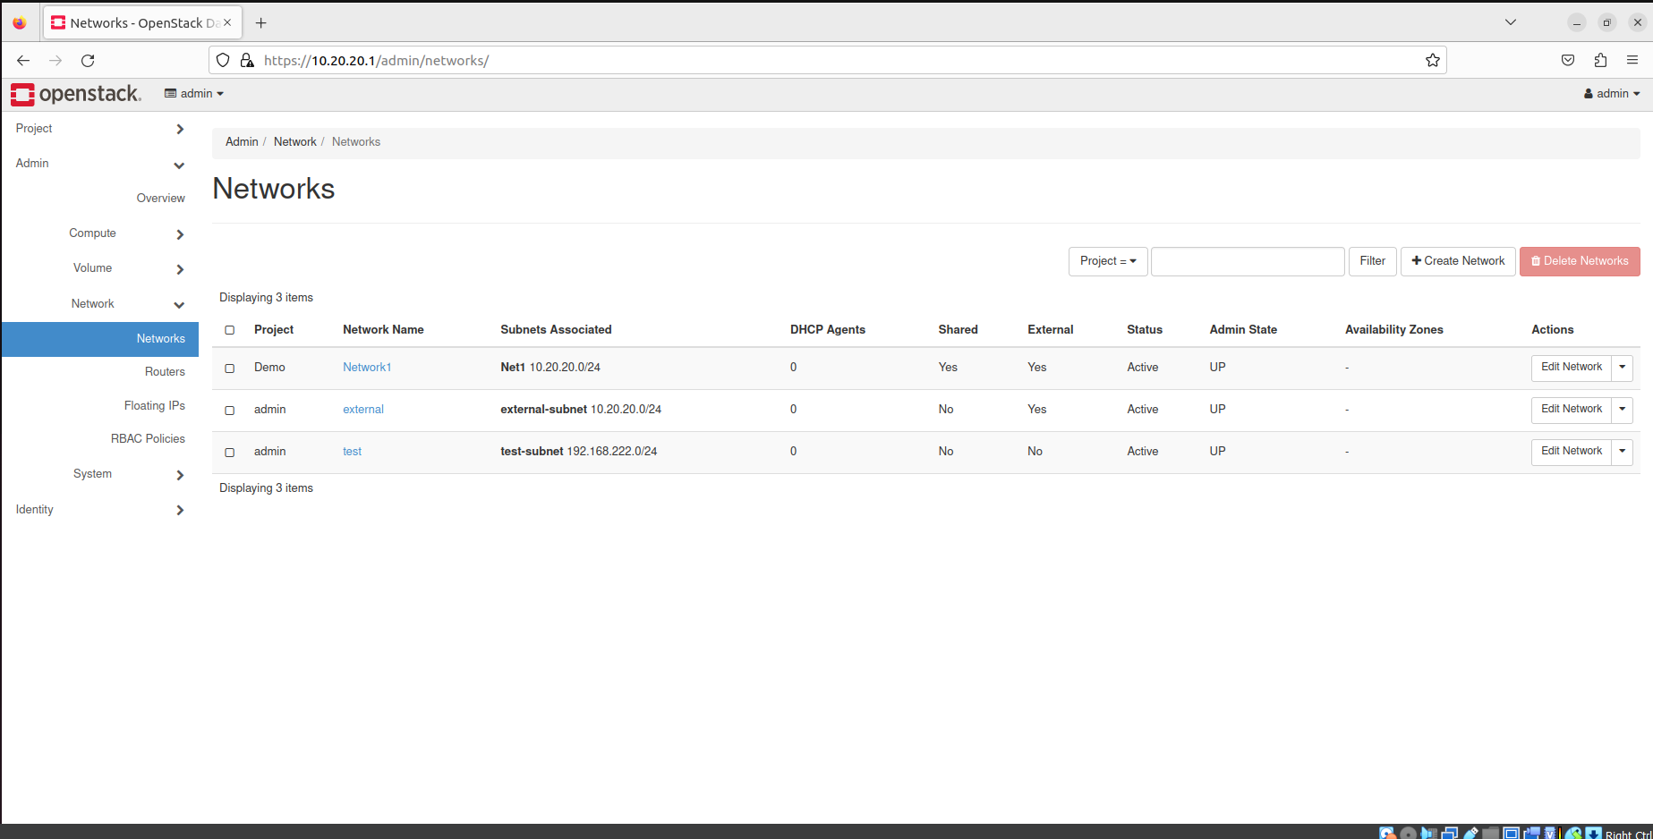

Step 13) Now log out and log back in as user created.

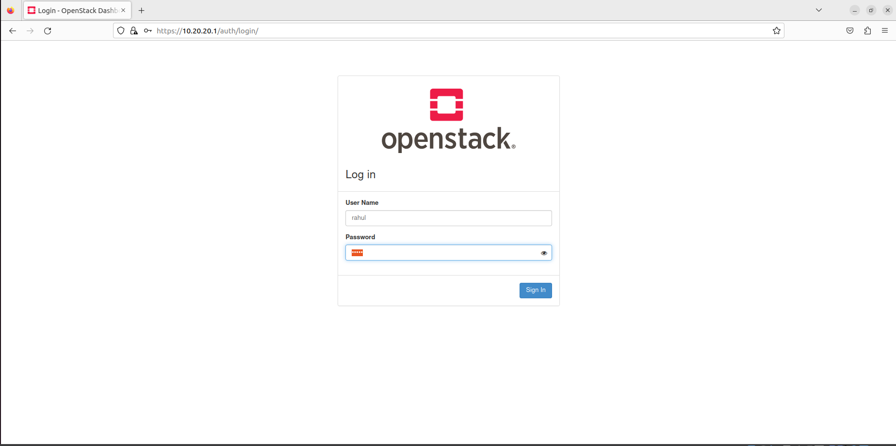

Step 14) And create an instance.

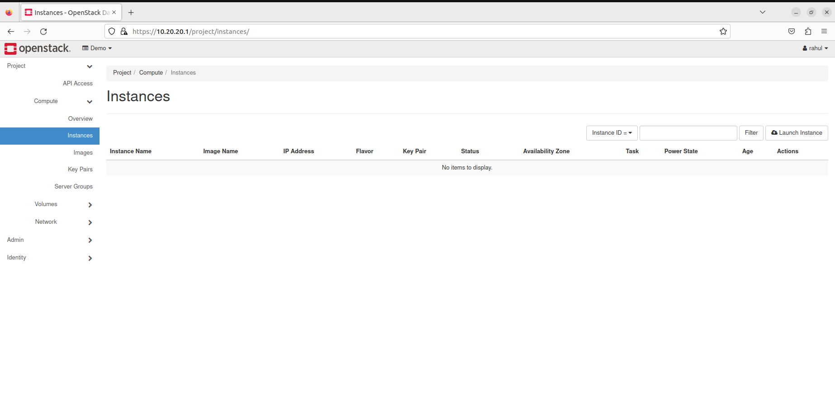

Step 15) Give it a name.

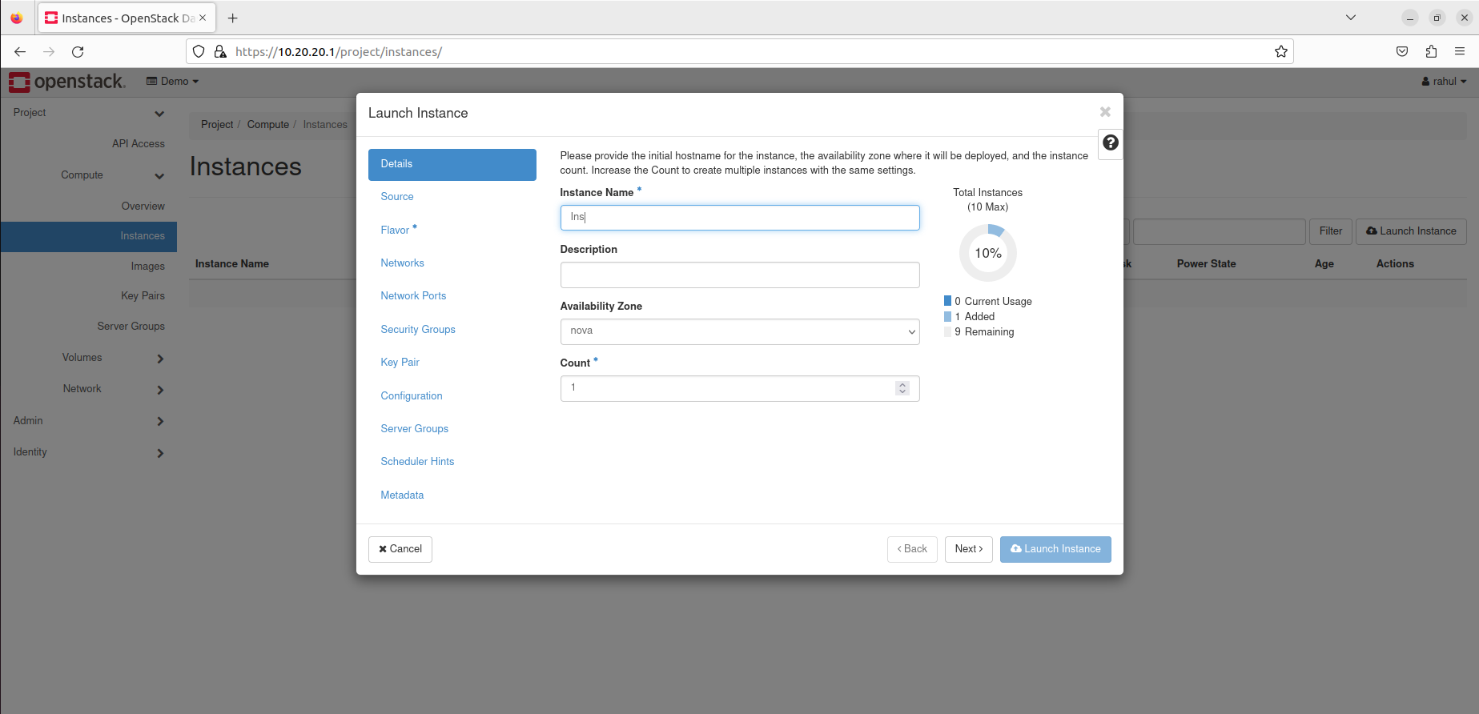

Step 16) Select an image.

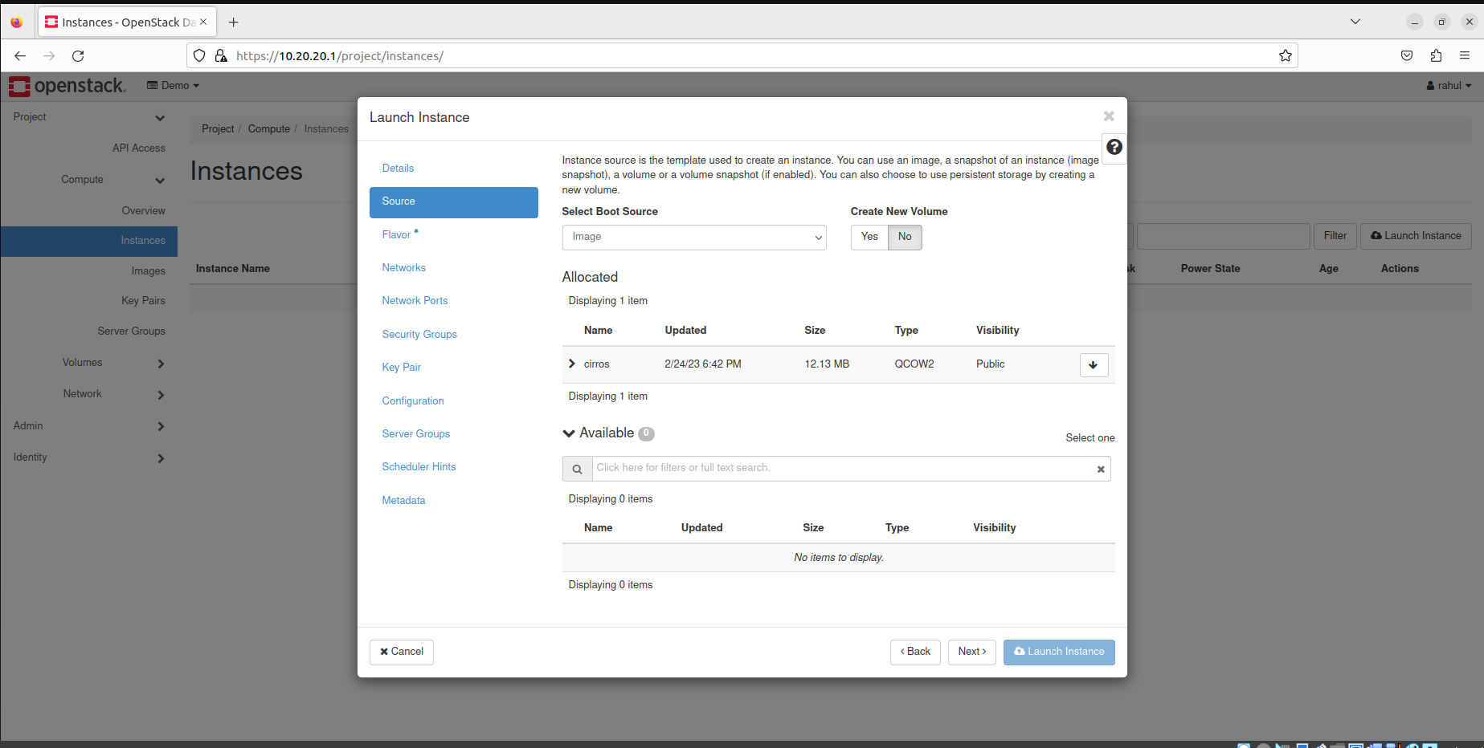

Step 17) Select flavor according to requirement.

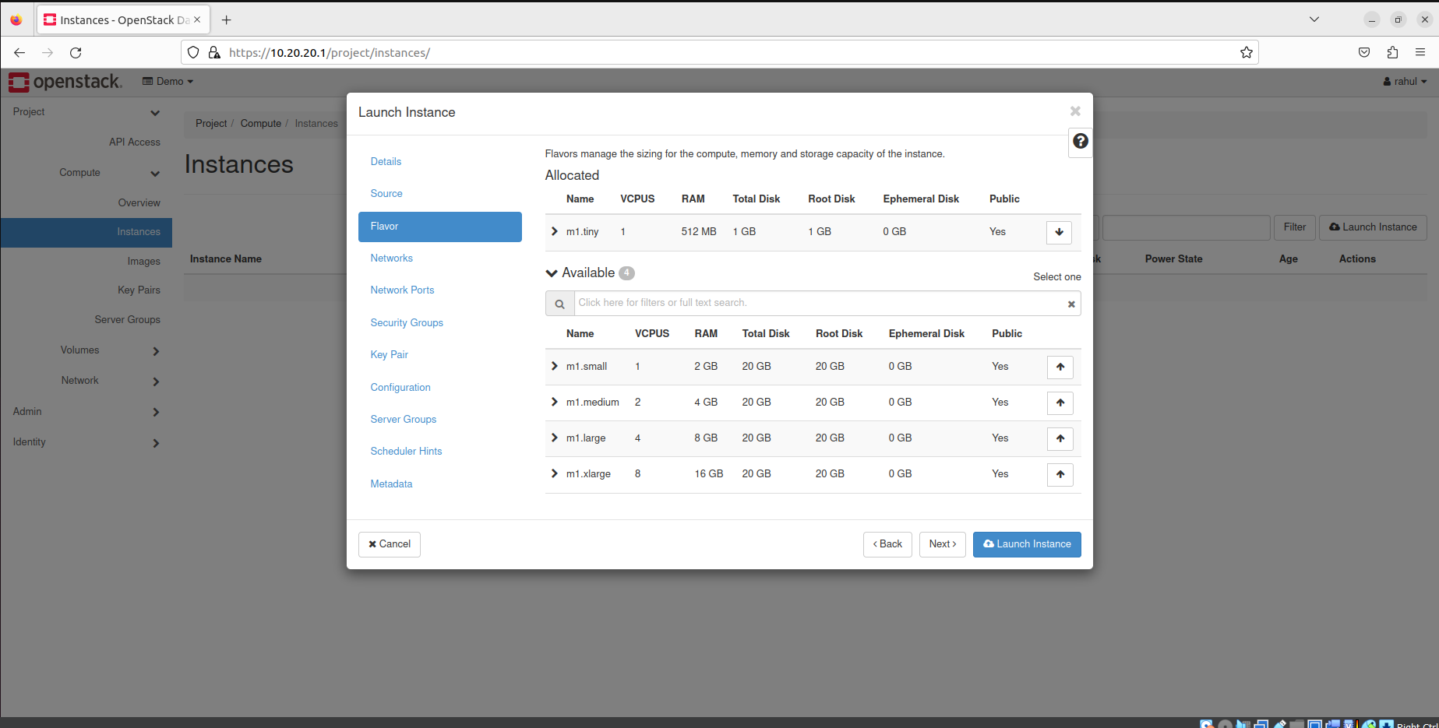

Step 18) Select network created.

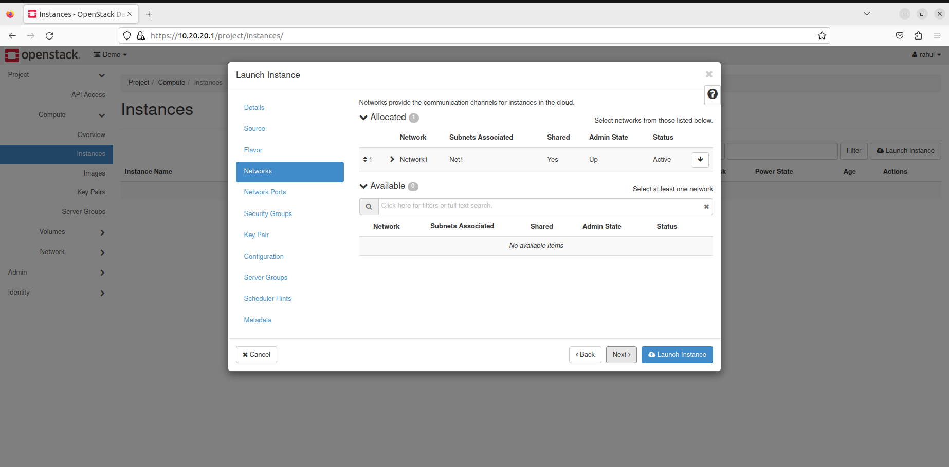

Step 19) Select any key pair created and launch instance.

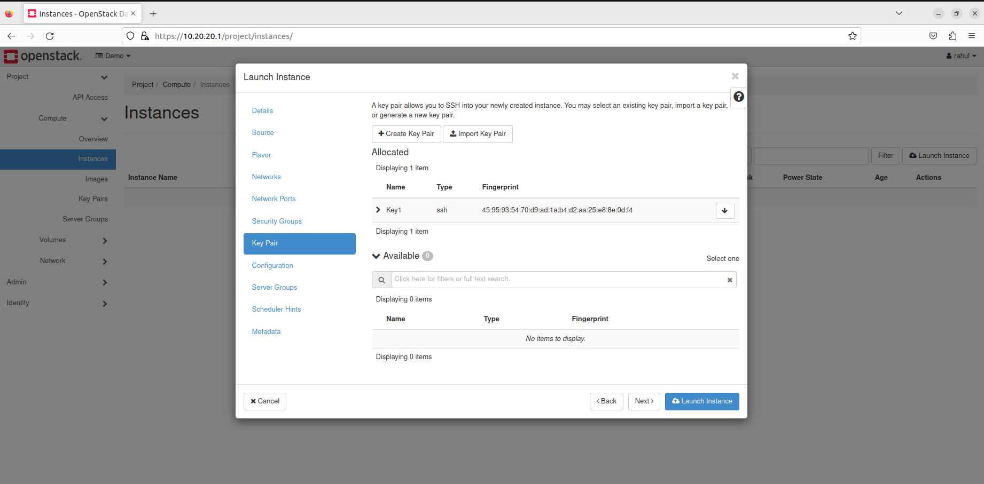

Step 20) Instance will be created.

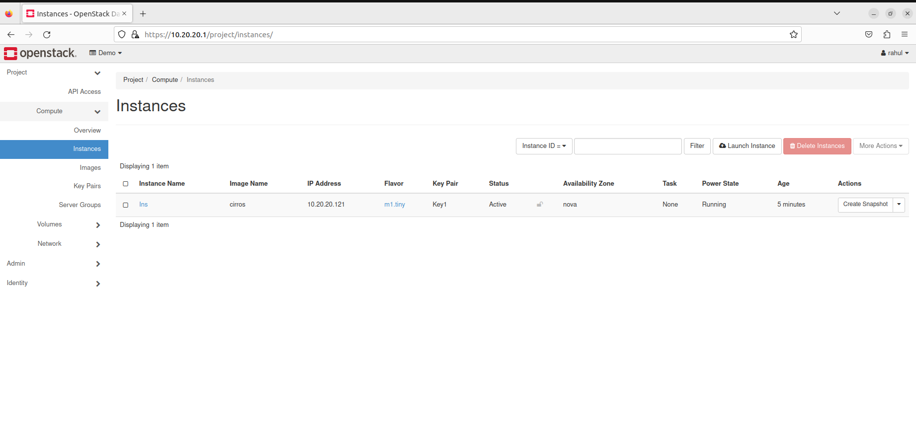

Step 21) Now logout and log back in as admin.



Step 22) Go to Admin -> Overview, you can see your project.

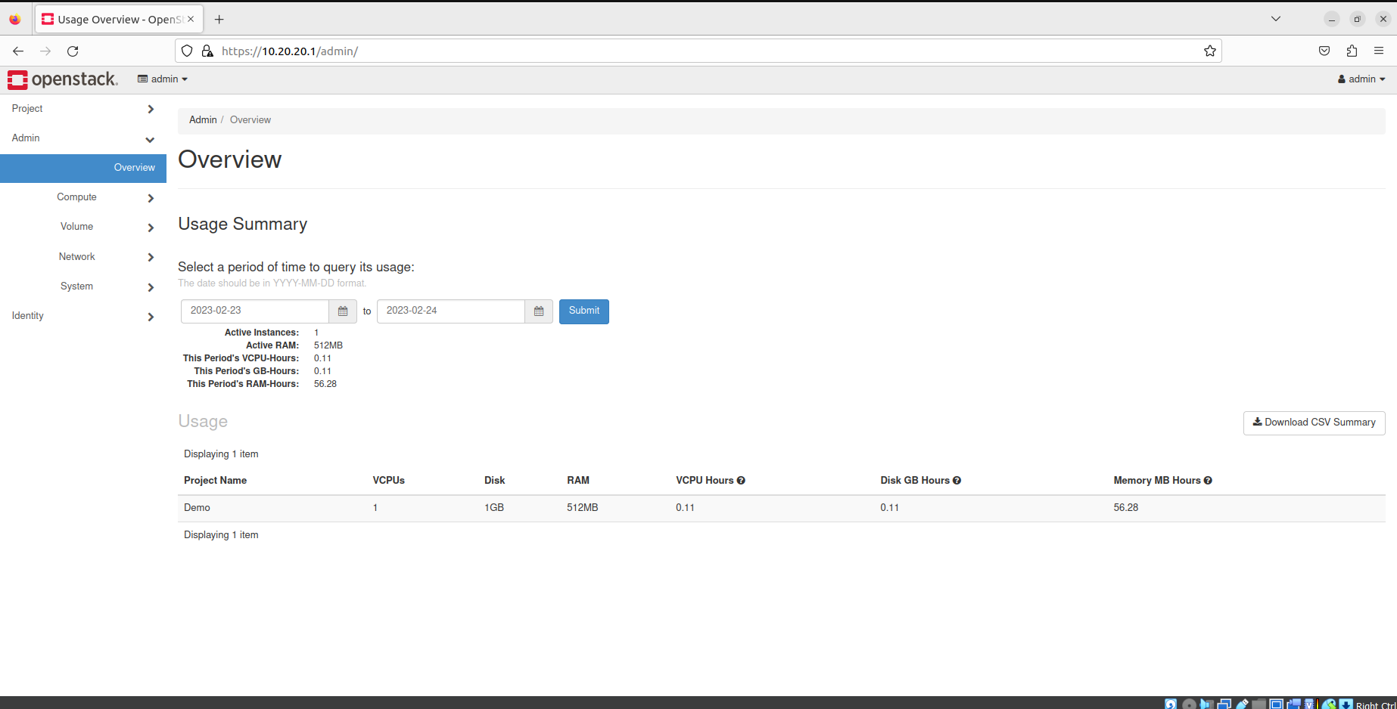

Step 23) Go to Identity -> Projects, and select your project -> project usage.

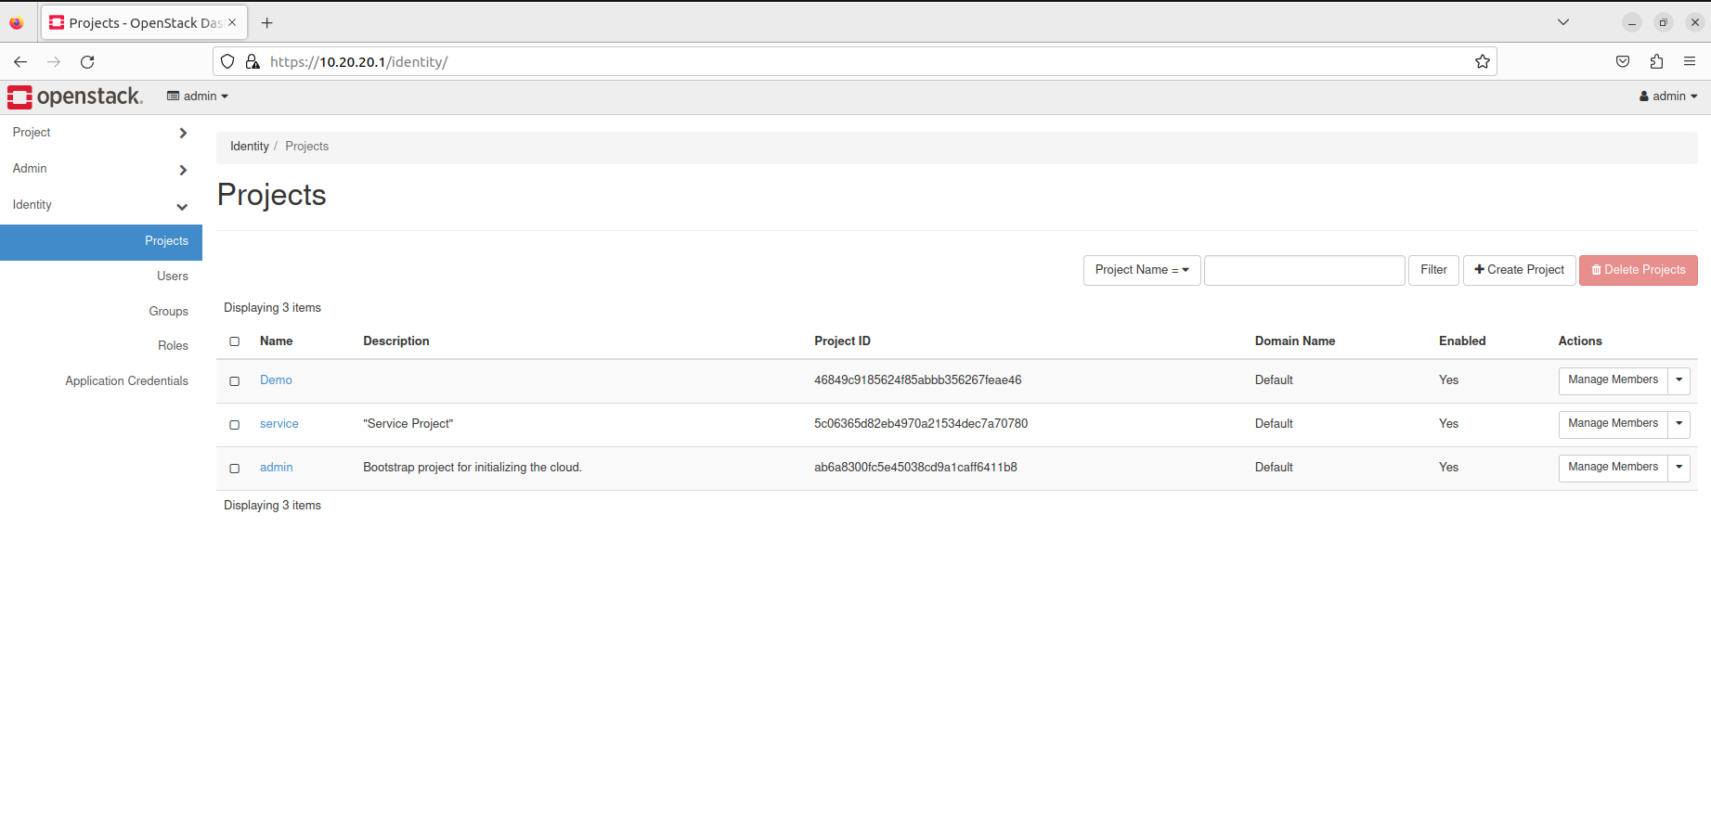

Step 24) You will be able to monitor your project.

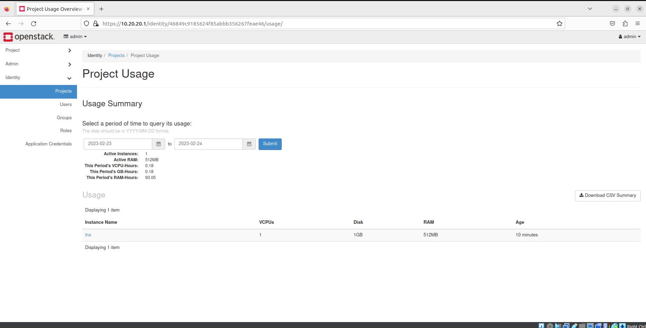

Step 25) Now go back to project.



Step 26) And click on Edit project, here you can add or remove members from project.

